**Computer Project 2: RLC Circuits**

We have the equation: LQ’’(t)+RQ’(t)+(Q(t))/C = 10cos(w*t)

Let x(1) = Q(t) and x(2) = Q’(t). Therefore, Q’’(t) = x’(2).

So, we have the differential equation: dxdt2 = -5*x(1) - 4*x(2) + 10*cos(omega*t)

1. Note: I was unable to find a way to save the graphs, so I had to take a screenshot. Sorry about the low quality. Each graph is the same except that omega is = 16,8,4,2,1,0.5,0 respectively. It’s obvious to see that as omega increases, frequency increases. However, as omega increases, the amplitude decreases. This is more obvious to see at the higher omegas than at the lower.

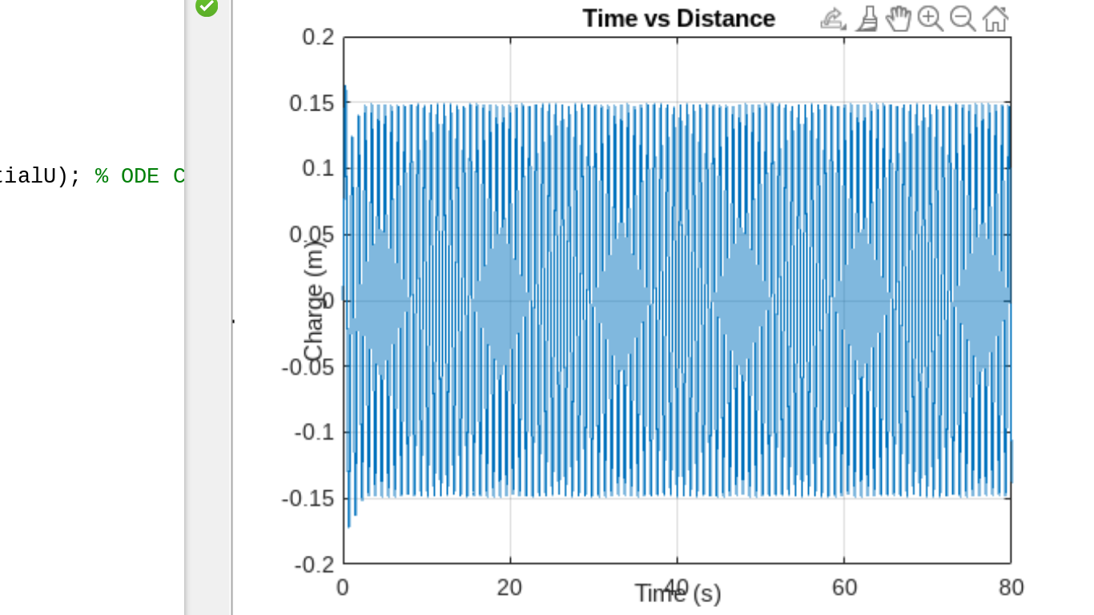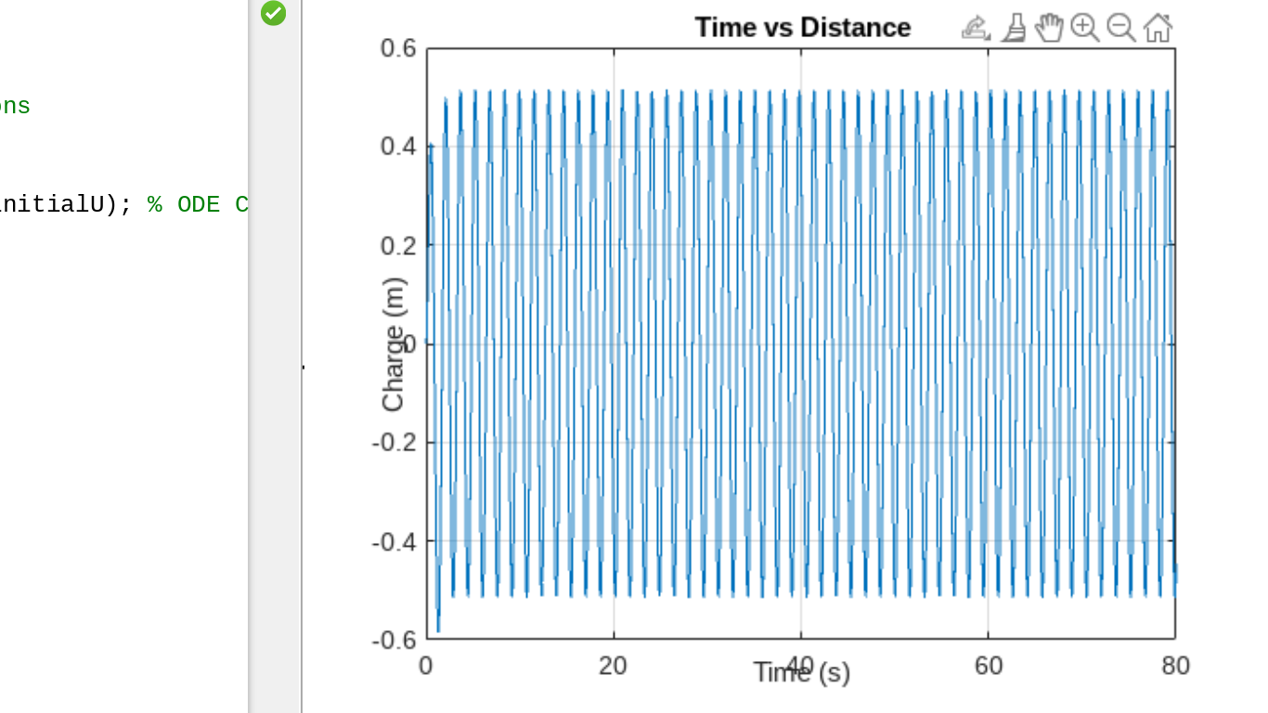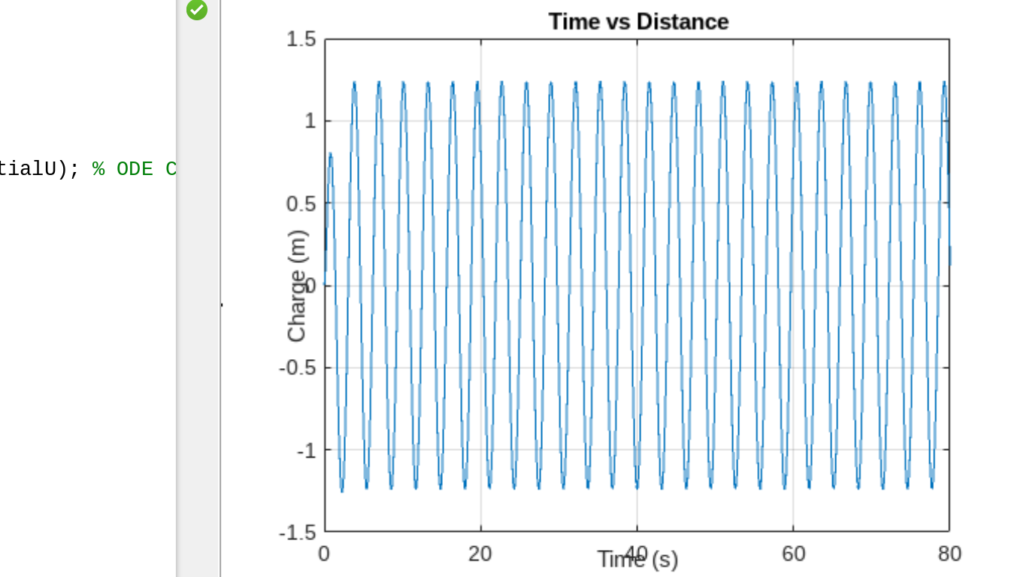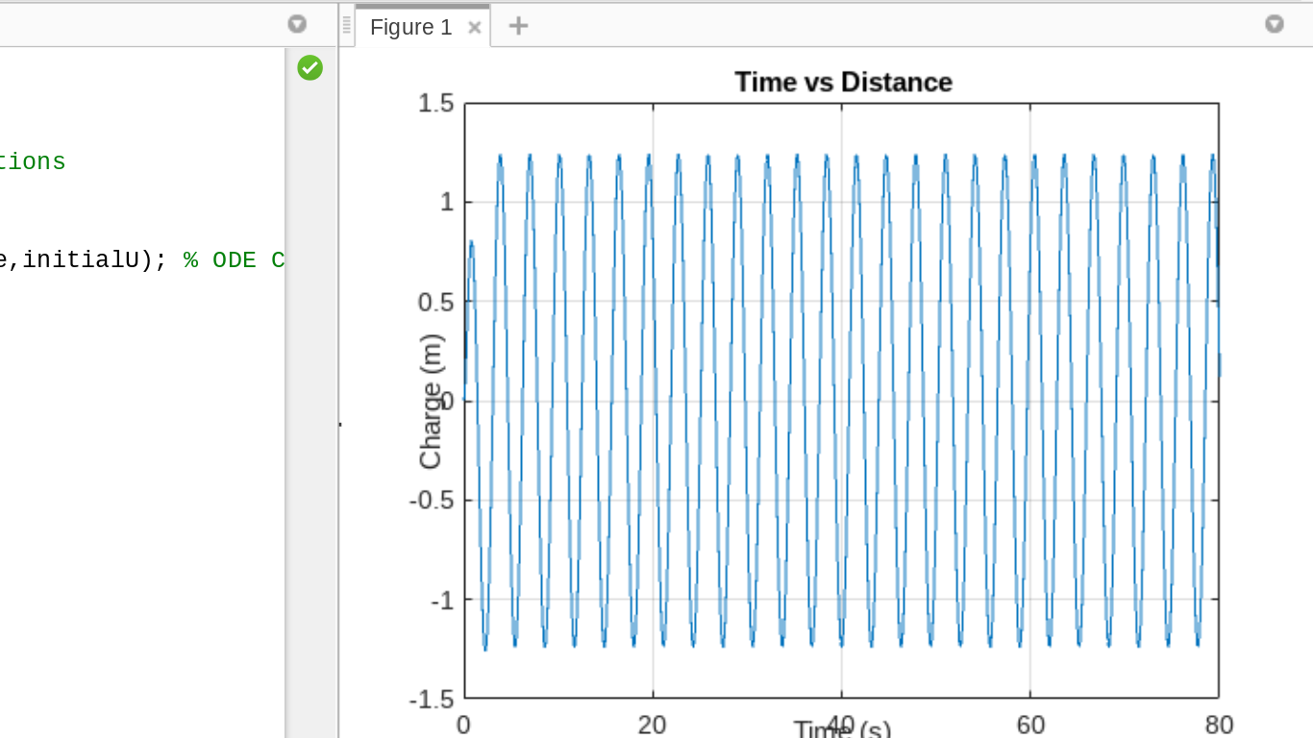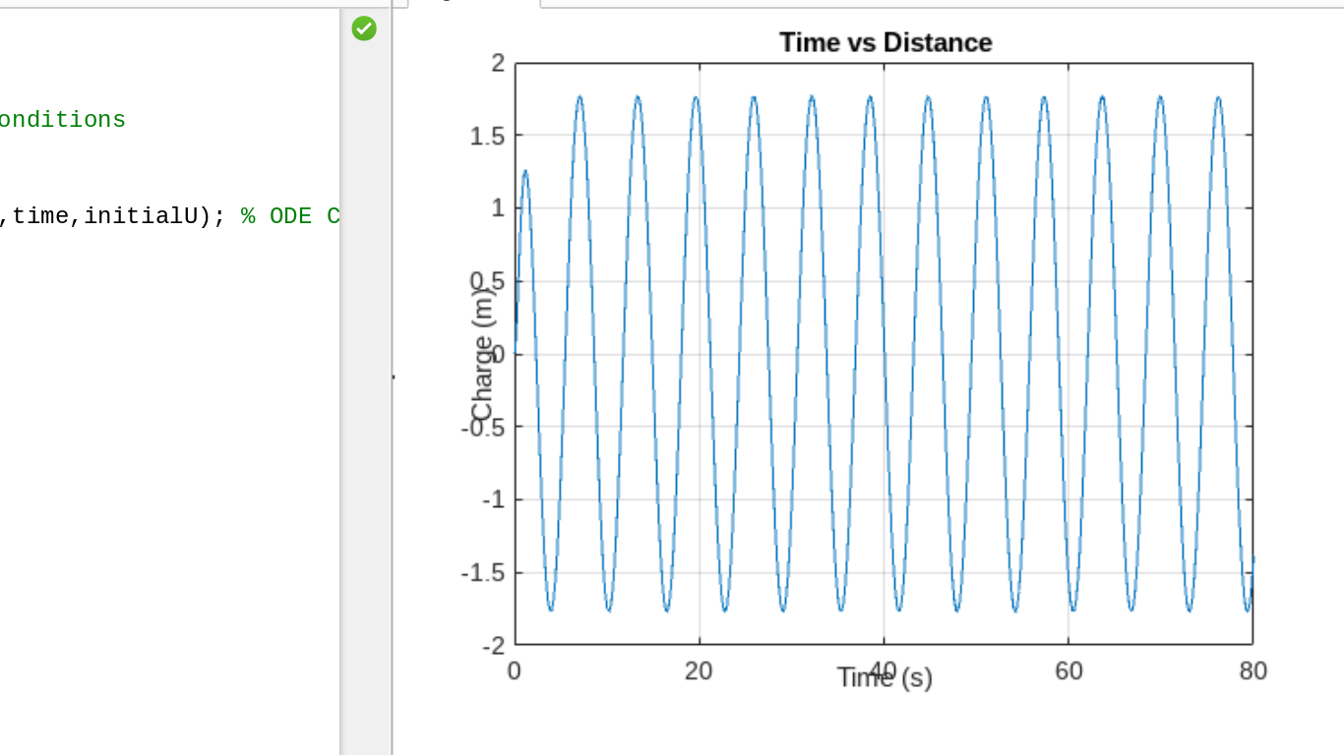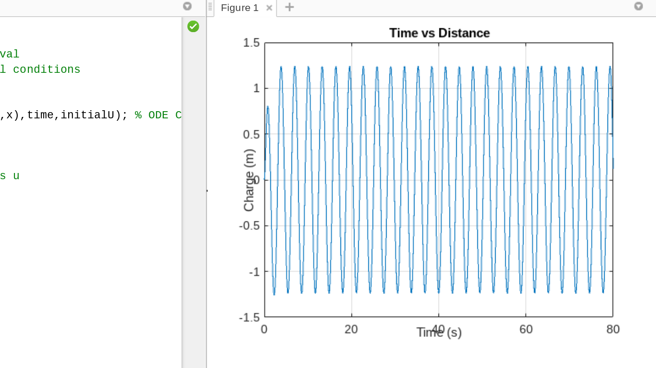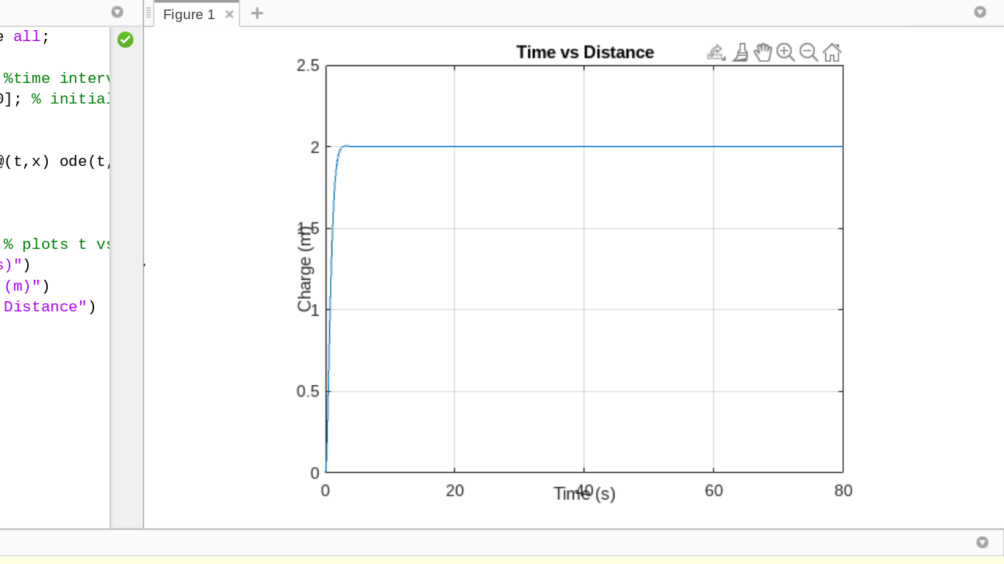

1. As omega approaches 0, A(w) approaches 2. The exact opposite is also true. The further omega goes from 0, the smaller A(w) becomes. However, after getting to larger and larger values for omega, the graph starts to look a little odd. The screenshot below shows w = 500. This trend is seen early. It is similar when w = 8.

As the displacement of a spring starts oscillating more frequently, the length of its amplitude (how far it goes up) decreases. An equivalent statement to this would be as the charge (Q) starts oscillating more frequently, its amplitude (how much the charge is changing) decreases. This is a beats oscillation because there’s rapid frequency, but slow varying of A(t) (at first).

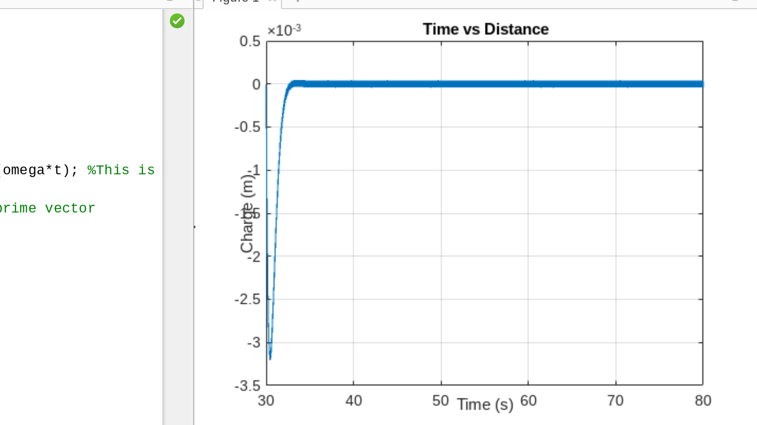

PIctures of my ode45 setup:

